Social Media - Web Scraping Using Python

Assignment submitted to
Graduate School at
The University of Arkansas at Little Rock

in partial fulfillment of
requirements for the graduate course of
202510 Spring: Data Science - Technologies (9U1)

in

March 2025

by
Deepak Singla

Instructors
Dr. Elizabeth Pierce
and
Dr. Serhan Dagtas

Assignment Instructions

For this assignment, check out this Python Web Scraping Tutorial - https://www.geeksforgeeks.org/python-web-scraping-tutorial/. Try implementing one of the techniques and submit your output (along with a brief description of the technique you used to do some simple web scraping). Submit your work to the Assignment Folder.

ABSTRACT

For the purpose of the assignment, I have chosen https://cognitiveclass.ai/courses page.

Following tools and libraries have been used to demonstrate the process of webscrapping from a public page.

- https://colab.research.google.com/ as the platform to run the code
- Python
- Request Module from Python
- BeautifulSoup Module from Python

Steps followed

- Send a request using URL
- Parse the response from the requested URL
- Find the content web scrapping is done from parsed data by searching html document on tags.

Code Snippet

Following code snippet has been used to extract titles from the requested URL.

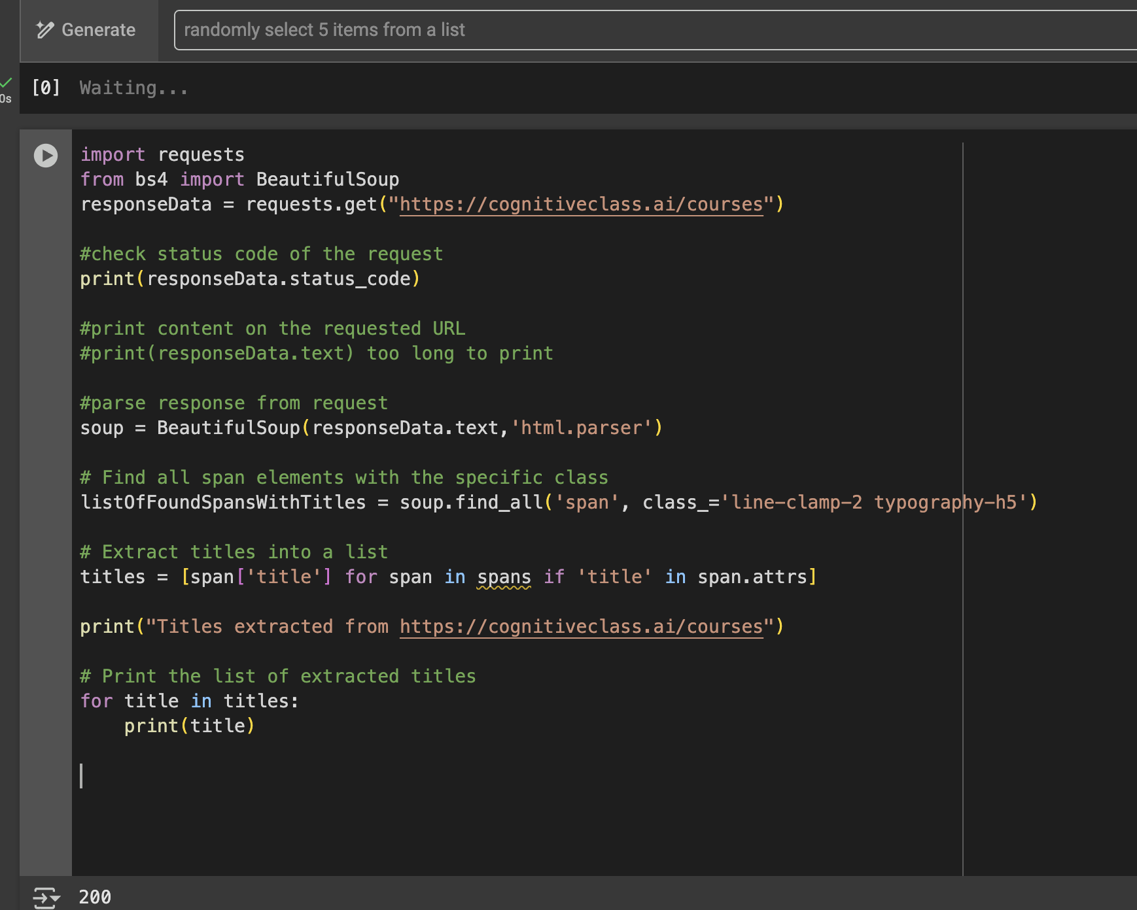

Using requests module, a get request is sent to the requested URL and response in save in a variable responseData.

Using BeautifulSoup library html in responseData is parsed. Then the parsed is searched using method find_all on html tags and class name.

Output

Following is the final output of the code above.

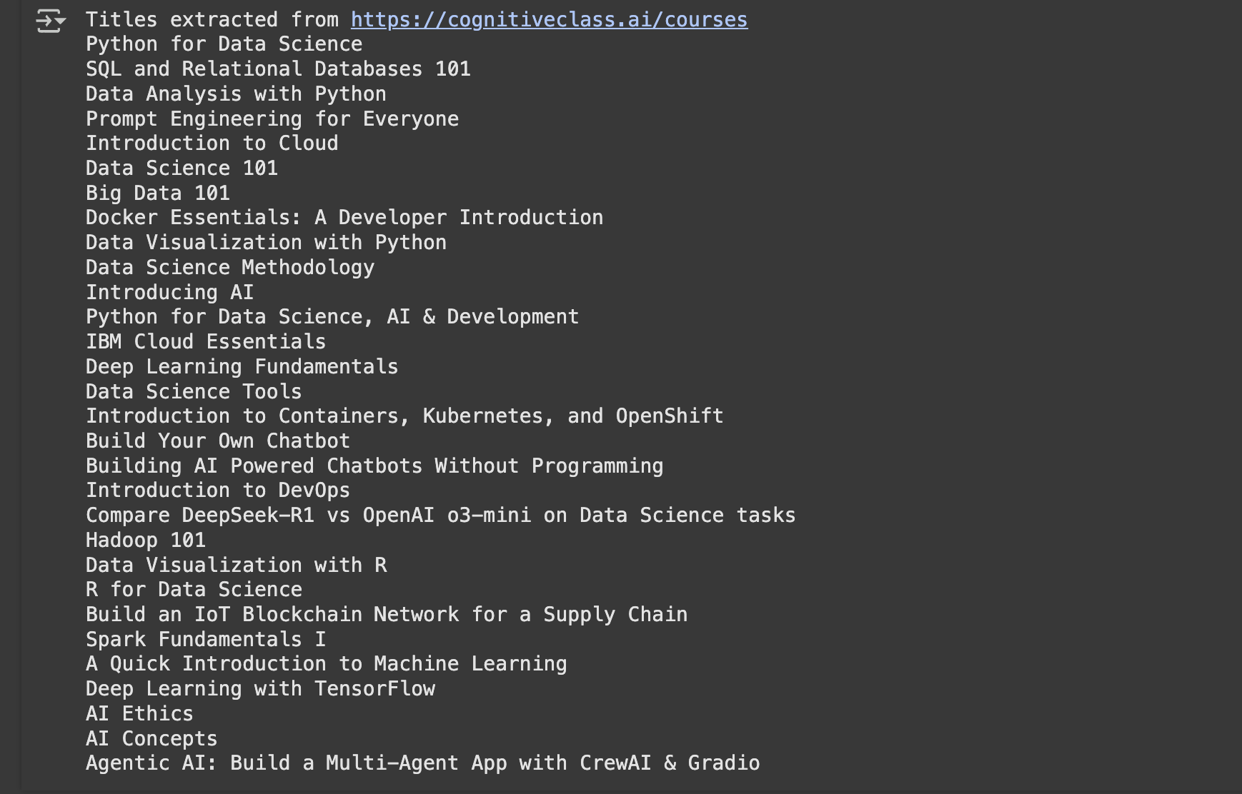

Credits

Report format has been copied from

https://www.proquest.com/pqdtlocal1009983/docview/2902800999/fulltextPDF/C967C462E7DF4DF2PQ/1?%20Theses&accountid=14482&sourcetype=Dissertations%20

Other References

https://cognitiveclass.ai/courses

https://www.geeksforgeeks.org/python-web-scraping-tutorial/#requests-module

